Project 2
16-bit ALU, Register File and Memory Read/Write Module

CS M152B
Summer 2004
7/25/2004

Group #4
Ho, Hing Kei
Vega, Javier
Yu, Wei Jun

Background and Specification

This project required a 16 bits ALU, a register file and a memory access unit. The 16 bits asynchronous ALU would perform addition, subtraction, bitwise AND, bitwise OR, increment, decrement, complement, logical shifting, arithmetic shifting and comparison. Moreover, the register file should include eight 16 bits registers and have two read ports and one write port. Finally, the memory access unit would be consisted of a memory write interface, a memory read interface and the Sraminterfacewithsupport-sv02.vhd and its associated files which were created by the School of Computer Science and Electrical Engineering at the University of Queensland in Australia. All these parts would be put together so that data from the register file and SRAM could be used in ALU and data from ALU could be stored in the register file and SRAM.

To meet the specifications stated above, alu.sch, memaccess.vhd, regfile.sch and simmodule.vhd were made. The schematic design in the alu.sch would function as the ALU. Detection of zero output would also be done in this file through a zero_detect component. Under this file, addition, subtraction, increment and decrement operations were performed in the add.sch. Also, this add.sch gave a high overflow signal when overflow happened in these four operations. Bitwise AND and OR operations were done in the logical.vhd. Finally, logical shifting, arithmetic shifting and overflow detection of shifting were executed in the shift.vhd.
ALU Ctrl | Function
0000 | S = A + B
0001 | S = A – B
0010 | S = A & B (bitwise)
0011 | S = A | B (bitwise)
0100 | S = A + 1
0101 | S = A – 1
0110 | S = ~A
1100 | S = A << B(3:0) logical
1110 | S = A >> B(3:0) logical
1000 | S = A << B(3:0) arithmetic
1010 | S = A >> B(3:0) arithmetic
1001 | If A < B  S = 1  Else  S = 0

In the regfile.sch, there were eight 16 bits registers. Register zero would always contain a 16 bits zero while others could be used to store or output any 16 bits data. Two pieces of data could be obtained from any two registers each time while any one register could be written in a clock cycle.

The memory access unit was built in the memaccess.vhd, which connected memorywrite.vhd, memoryread.vhd and Sraminterfacewithsupport-sv02.vhd. While memorywrite.vhd was the memory write interface which communicated with the Sraminterfacewithsupport-sv02.vhd and acted as a state machine to do the write operation to the SRAM, memoryread.vhd was the memory read interface which communicated with Sraminterfacewithsupport-sv02.vhd and acted as a state machine to do the read operation to the SRAM. The memory write interface would work according to the following protocol:
When writing a data, within the same clock cycle
do
{
send the data on WriteData;
send the addr on WriteAddr;
assert IssueWrite;
}
The WriteDone signal goes high for one clock cycle to indicate that the write operation is done.
Similarly, the memory read interface would work according to the following protocol:
When reading a data, within the same clock cycle
do
{
send the addr on ReadAddr;
assert IssueRead for one cycle;
{
After a number of cock cycle, the ReadDone signal goes high for one cycle and the desired data is available at ReadData.
The whole memory module would work according to the following protocol:
To read:
within the same clock cycle,
{
put the address at RdAddr;
assert MemRd for one cycle
}
After a number of cock cycle, the RdDone signal goes high for one cycle and the desired data is available at Dout.
To Write:
within the same clock cycle,
{
put the address at WrAddr;
put the data at Din;
assert MemWr for one cycle;
}
The WrDone signal goes high for one clock cycle to indicate that the write operation is done.

Finally, simmodule.vhd would be a state machine which generated inputs to the ALU, register file and memory access unit. In this way, our design was simulated to do any calculation in the ALU, as well as accessing the SRAM and register file.

Design Approach and Challenges
ALU:
The first step taken in the design of the ALU was examining the functionalities it needed to support. By looking at the project specification, it became apparent that many of the functions were very similar and thus could be grouped together. For example, the bitwise AND and OR operations could be thought of as a subset, and the four shift operations as another subset, while the remaining operations as yet another subset. The modularity and simplicity of this approach allowed the designer to see a clear and concise top level picture. Additionally, this simplified the design of each subpart, by grouping together similar functions. For instance, in building the shifter, the designer could afford to focus only on the shifting operations and not worry about the implementation of other parts of the ALU.
Going forth in this direction, the top-level view of the ALU has three main modules – one to support shift operations, another to support logical operations, and a third to support the remaining operations. The decision to group together the logical AND and OR operations into a single module was obvious, since they perform very similar functions. The same was true of the shift operations. We have logical and arithmetic shifting operations both to the left and to the right, and they could be supported by a single module.
The remaining operations are add, subtract, increment, decrement, two’s complement, and less-than, and they could be grouped and implemented in an arithmetic module. An adder can handle the add and subtract operations, as well as increment and decrement, since they basically add and subtract one, respectively. Then, we had a decision on the implementation of the less-than operation. One choice was to use a pre-built comparator, but this would have meant that the comparator would be useful for only one out of twelve operations, and would sit idle with absolutely nothing to do for all the other eleven. To achieve better efficiency, instead of using a comparator, we could make use of the adder. To compare A and B, we could subtract B from A and examine the result. If the answer is negative, then we know A is less than B. Besides helping compute the less-than operation, the adder could also be used to calculate the two’s complement of A. The two’s complement can be computed by inverting each bit of A, and then adding one. Equivalently, we could add zero and set the carry-in. This is a job which the adder could easily handle. So, again, the add, subtract, increment, decrement, two’s complement, and less-than operations are handled by the arithmetic module.
The main overall ALU design consists of the arithmetic, logical, and shift modules, plus a multiplexer to select the output of the appropriate module depending on the operation. At the top level, the design also has logic to detect overflow, which could be set either the shift module or the arithmetic module. We also add the capability to detect a zero result.

Register File:
The registry file component is a module that allows to store 8 values 16 bit long, to be exact only 7 values can be stored due to the specification that registry id 0 will always have the value 0x0000 hex. The other registries enumerated from 1 to 7 with a bus 3 bits long can be writing with one clock cycle. The registry file allows reading two values of the registries simultaneously, but only one value can be rewriting. In general the registry file is a module used to store values up to 7, and read from 2 of the at the same time. The component is used in the project to store non volatile data that can be read to the ALU component and then operations on the two values can be stored back again in the registry file. The only requirement of writing on the registry file is one clock cycle needed by the component used to store the data.

The basic design of the registry file in schematics is:

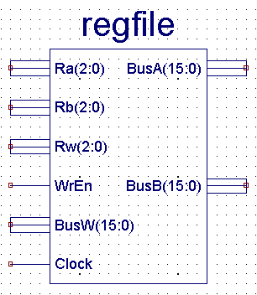

As indicated in the specs there are 6 inputs: The buses Ra, Rb, Rw, BusW and the signals WrEn and Clock. The first 3 inputs determine the bus data to be Read in bus A, B and the registry to be written (Rw). The signal WrEn is require to enable the writing and the clock to actually perform it. The busses BusA and BusB are the actual read values from the registry file.

Memory Module:
The memory module and its sub-units were constructed in VHDL code as required. The high level design diagram of the memory module is shown below:
MemRd
MemWr
RdAddr
WrAddr
Din
ResetL
CLK
RdDone
WrDone
Dout
16bits
16bits
16bits
16bits
Memory Module
(memaccess.vhd)
To write or read the SRAM, the memory module would follow the protocol stated before.
The high level diagram of memory read interface is shown below:
CLK
IssueRead
ResetL
ReadDone
DoRead
Memory Read Interface
(memoryread.vhd)
CanRead
ReadData
ReadAddr
Sraminterfacewithsupport-
sv02.vhd
16bits
16bits
To read the SRAM, the memory read interface would follow the protocol stated above.
The high level diagram of the memory write interface is shown below:
CLK
IssueWrite
ResetL
WriteDone
DoWrite
Memory Write Interface
(memorywrite.vhd)
CanWrite
WriteData
WriteAddr
Sraminterfacewithsupport-
sv02.vhd
16bits
16bits
To write the SRAM, the memory write interface would follow the protocol stated above.
The actual units that needed to be designed were the memory read interface and the memory write interface. They would be two similar state machines which worked according to the protocol stated in tutorial 2. In the memory module, it was only required to connect these two interfaces with the Sraminterfacewithsupport-sv02.vhd.
The only challenge in designing the memory module was to understand the protocol to communicate with Sraminterfacewithsupport-sv02.vhd and to implement a state machine similar to the one in tutorial two. To write the SRAM:
- Place the address and data to WriteAddr and WriteData respectively.
- Wait for CanWrite signal to be high
- Set DoWrite to be high
- Wait for CanWrite to be high again (it will be low after seeing a high DoWrite,) which indicates that the write operation is done.
Similarly, to read the SRAM:
- Place the address to ReadAddr.
- Wait for CanRead signal to be high
- Set DoRead to be high
- Wait for CanRead to be high again (it will be low after seeing a high DoRead,) which indicates that the read operation is done and the desired data is available at ReadData.
After understanding this, state machines to do write and read operation could be designed at ease. For the rest of the memory module, they were just connecting signals to their right pins.

Implementation Details
Top Level:
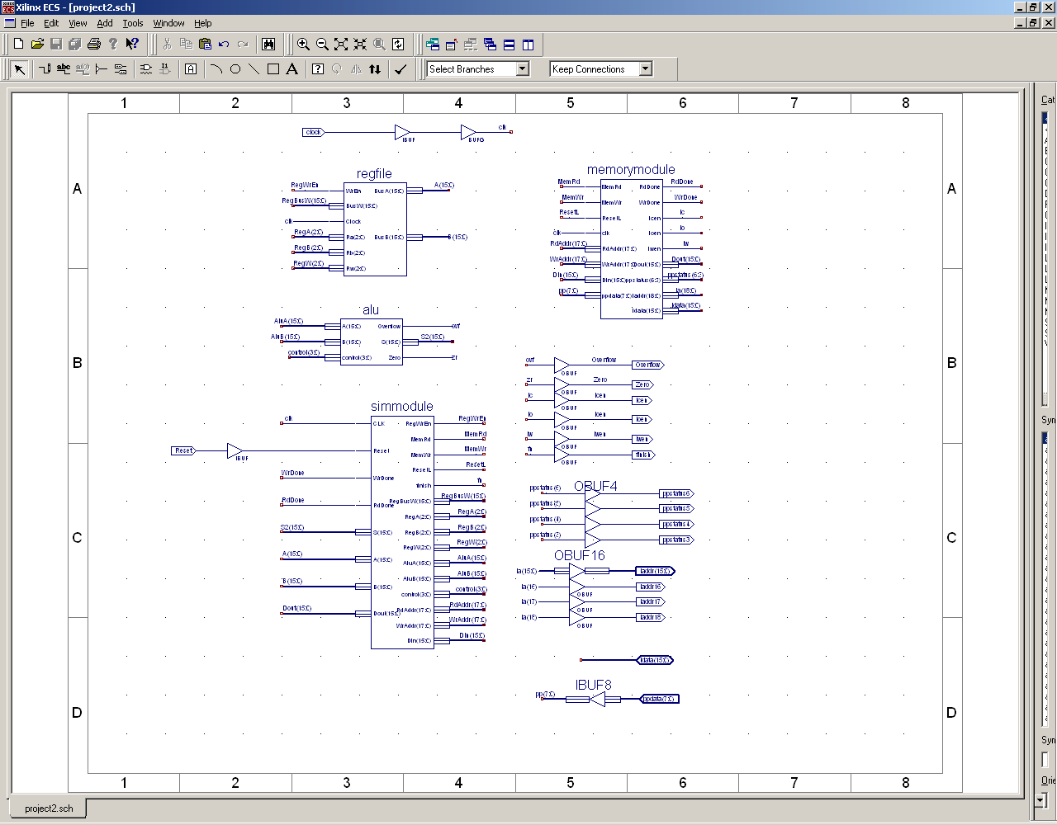
Above showed the connection of ALU, memory access unit, register file and the simulation state machine.
ALU:
The top-level multiplexer is controlled by a control unit, which maps the ALU operation to the correct select signal for the mux. This control unit is implemented in VHDL, taking ALUCtrl(3:0) as inputs and outputting a two-bit selection bus to the mux. The VHDL code simply consists of three if statements, conditioning on ALUCtrl(3:0).
The add, logical, and shift modules each take in three input buses: A(15:0), B(15:0), and ALUCtrl(3:0). Each unit produces a 16-bit result. In addition, the arithmetic module and shift module each outputs an overflow signal. Since an ALU overflow occurs if either overflow is high, we fed them into a two-input OR gate. But since ALU overflow is not possible for two’s complement, less-than, and the two logic operations, we should ensure overflow is always disabled for those operations. That was the motivation for creating the overflow-enable module, which takes ALUCtrl(3:0) as input and outputs an enable signal for only the appropriate operations. The overflow enable signal and the output from the two-input OR gate are fed into a two input AND gate, to produce the ALU overflow signal. The overflow enable module was also designed in VHDL, and consists of simple if statements conditioning on ALUCtrl(3:0).
The project specifications also called for a Zero signal, to be raised when S = 0. This can be accomplished through a simple VHDL module. It is basically an if-statement conditioning on S, and the module raises the Zero signal if it sees S = 0.
The logical module was implemented in VHDL and was straightforward. Taking A(15:0), B(15:0), and ALUCtrl(3:0) as inputs, it decides whether to do an AND or an OR operation on the data buses based on the control bus, and outputs the result.
The shifter was implemented entirely in VHDL as well. It takes A(15:0), B(3:0) and ALUCtrl(3:0) as inputs and outputs an overflow line and a 16-bit data bus. The shifting was implemented on a case-by-case basis, based on the op code and on the shift amount specified in B(3:0). For each shift operation – logical left, logical right, arithmetic left, arithmetic right – the VHDL code lists all sixteen possible B(3:0) values, and for a specific shift position, lists all sixteen output bits. Additionally, the shifter must detect overflow, which happens when the last bit shifted out is a one. Thus the overflow signal of the shift module is equivalent to the last bit shifted out.
The most complex module is the arithmetic module, which was designed in schematic with the help of some VHDL modules. At the heart of the arithmetic module is the ADSU16 adder/subtracter. It provides services to all operations which use the arithmetic module. Each of the two inputs of the ADSU16 is selected by a mux. The first mux selects from A(15:0) and a 16-bit zero-bus (a bus of all zero signals), while the second mux picks from a 16-bit one-bus (a bus with all zeros except the least significant bit), B(15:0), and the inverted value of A(15:0).
For the add and subtract operations, the first mux selects A(15:0) and the second mux picks B(15:0). The ADSU16 has an input signal to specify either add or subtract. For increment and decrement operations, the first mux selects A(15:0) and the second mux picks the one-bus. In the case of a two’s complement operation, the first mux selects the zero-bus, and the second mux picks the inverted values of A(15:0) and set the carry-in for the ADSU16. This emulates the steps of inverting A and adding one to get the two’s complement of a number. For a less-than operation, the first mux chooses A(15:0) and the second mux picks B(15:0) and the ADSU16 is told to subtract. To completely implement the less-than operation, we needed a separate module to detect a negative ADSU16 result. This negative detection module was done in VHDL, and it takes as input the output of the ADSU16, A(15), B(15) and the ALUCtrl(3:0). The module determines whether the result was negative by looking at the most significant bit of the result from the ADSU16. However, this approach would only work if no overflow occurs, but we are not guaranteed that since A(15:0) subtract B(15:0) possibly produces overflow. That is the reason for also feeding in the A(15) and B(15) signals. If A(15) = 1 and B(15) = 0, we automatically know that A < B without looking at the result from the ADSU16. Similarly if A(15) = 0 and B(15) = 1, then A > B.
The design also includes a module to detect general overflow of the arithmetic unit. This unit was designed with VHDL and accomplishes overflow detection by examining A(15), B(15) and the MSB of ADSU16 result. It is able to detect the four possible overflow cases, as listed below.
Operation | A | B | Result
Add | Positive | Positive | Negative
Add | Negative | Negative | Positive
Subtract | Positive | Negative | Negative
Subtract | Negative | Positive | Positive
Schematic diagram of alu.sch
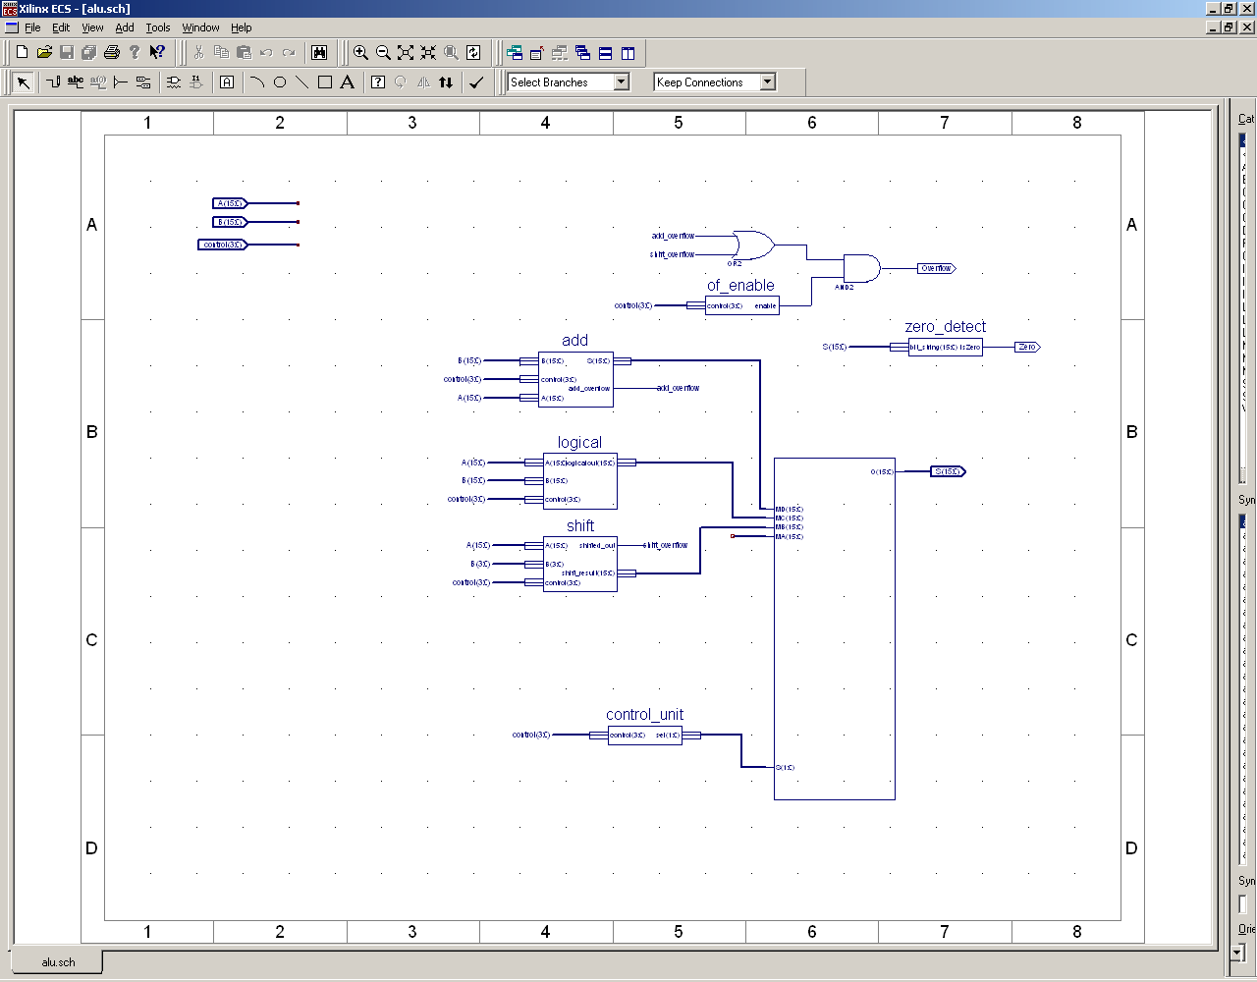
Schematic diagram of add.sch
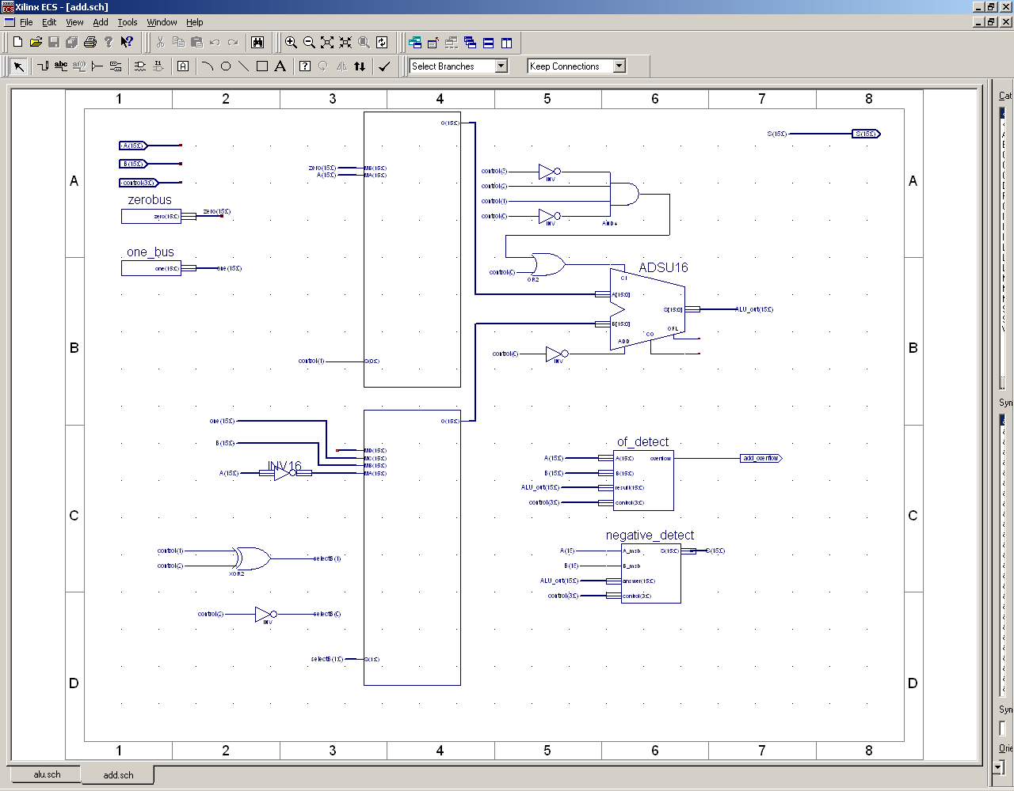

Register File:
The registry file was implemented in schematics to follow the specs indicated in the project sheet. Most basic component were required to implement the design and only one component was needed to be adapted using the CORE tool provided by the design tool. The component was a MUX that received 8 Buses of width 16 bits and selected only one to be outputted. That component was easily constructed following basic procedures from the tutorial 2. There is additional component that was used to store the data, which was the FD16CE which is a non volatile registry with a bus width of 16 bits. In our design we used 7 of those registry to store the 7 values required and we avoided to use one to store the registry 0. We connected the bus of registry 0 to ground making its output always zero.

Sample schematics of Registry File Implementation:

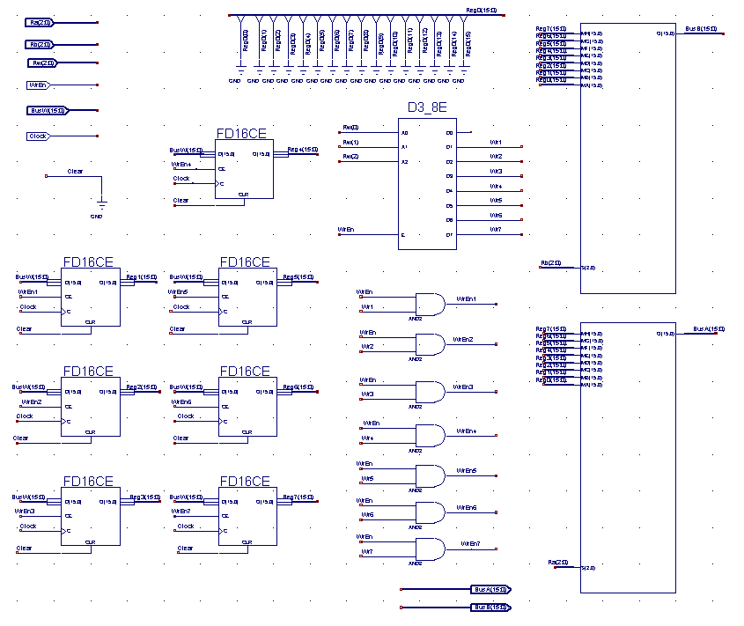

The connection of the design was very straight forward and can be looked at the schematics. There are 2 Muxes that select the values to be read, there are 7 registers that store the values, there is one Demux that is used select the register component that needs to write the data, and a few and gates with input/output connectors. All the registers have their input bus connected to the BusW bus signal, but the writing of the bus is selected with the Demux component that uses the value from Rw to select which register to write. The output of the registers goes to each one of the two Muxes which have connected the values from RA and RB busses to select which output to choose from. There are few gates used to select which register to write, but that is done only due to prevent writing to more than one registry in the cases of multiple clock cycles with changing values of WrEn, which can be observed on the schematics.

Memory Module:
The state machine of the memory read interface (memoryread.vhd):
State: stIdle
State: stDoRead1
DoRead = 1
State: stDoRead2
/ReadDone = 1
CanRead = 0
CanRead = 1
CanRead = 0
CanRead = 1
IssueRead = 0
IssueRead = 1
This design would communicate with the Sraminterfacewithsupport-sv02.vhd and follow the protocol stated in the specification.
Similarly, the state machine of the memory write interface (memorywrite.vhd):
State: stIdle
State: stDoWrite1
DoRead = 1
State: stDoWrite2
/WriteDone = 1
CanWrite = 0
CanWrite = 1
CanWrite = 0
CanWrite = 1
IssueWrite = 0
IssueWrite = 1
Also, this design would exchange signals correctly with the Sraminterfacewithsupport-sv02.vhd and follow the protocol stated in the specification.
In my design of these state machines, it was assumed that the write or read operation would be issued only after the previous one was done. However, a write operation or a read operation might still be issued simultaneously even when the SRAM was busy. Since the IssueWrite and IssueRead signals only went high for one cycle, the first states of my state machines were used to save the read or write command and wait for the SRAM to be free. In this way, a write operation and a read operation could be issued at the same time.
At the top level of the memory module, the three components, memoryread.vhd, memorywrite.vhd and Sraminterfacewithsupport-sv02.vhd, were wired together as designed in the high level diagrams shown above. In my design, RdAddr, WrAddr, Din and Dout were directly wired to ReadAddr, WriteAddr, WriteData and ReadData respectively to simplify the logic inside the memory module. To convert the 18 bits input address to the SRAM 19 bits address, zeros were added to the ReadAddr(18) nad WriteAddr(18). For other signals, they were connected to their corresponding pins.

Simulation
For clearer picture, please zoom in this file or run the simulation using the do files provided.
ALU:
The first operation was to compare A and B (1001). As shown above, 0111111111111111 was smaller than 1000000000000000, so S equaled 1.
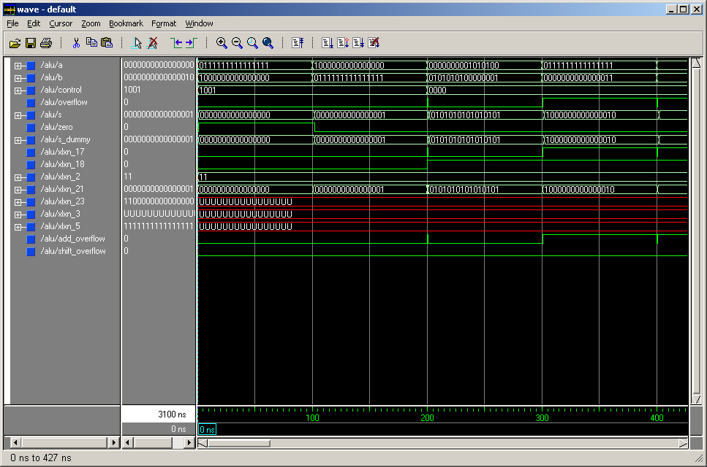
The second operation was to add several numbers. The first set of numbers was adding 1010100 and 101010100000001. The result was 101010101010101. The second operation, 111111111111111 adding 11, caused overflow. The rest of the adding operation was just serving as more examples. 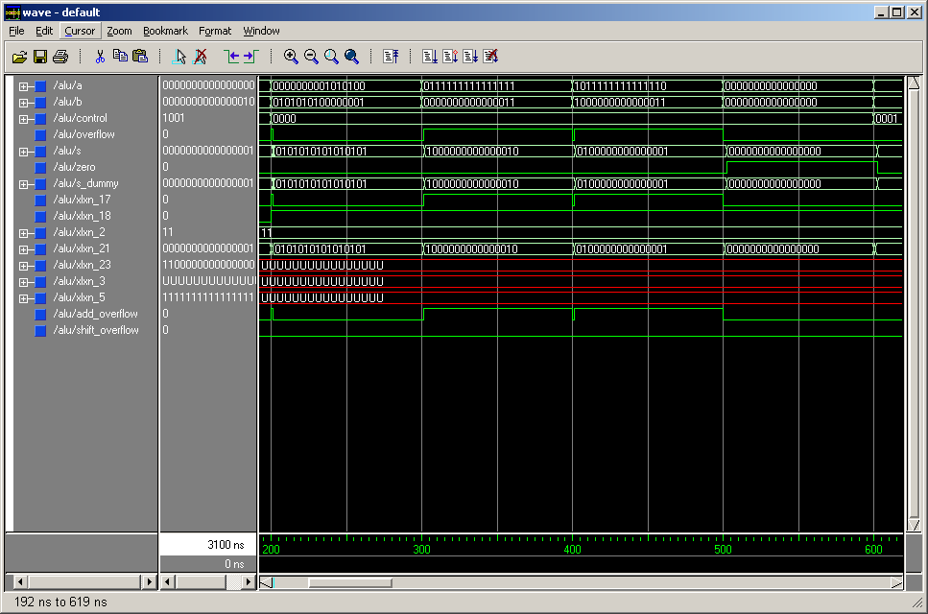
The Third operation was to subract several numbers. The first set of numbers was subtracting 11 from 111111111111111. The result was 111111111111110. The second operation, 1000000000000000 minus 111111111111111, caused overflow. The rest of the adding operation was just serving as more examples.
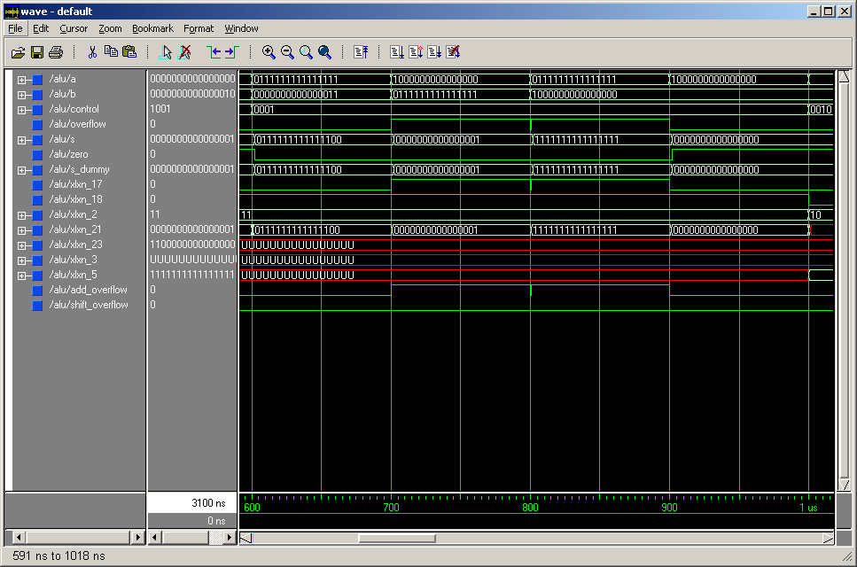
The forth operation was bitwise AND between 111111111111111 and 1000000000000001, which caused S equaled 1. The fifth operation was bitwise OR between 111111111111111 and 1000000000000000, which caused S equaled 1111111111111111.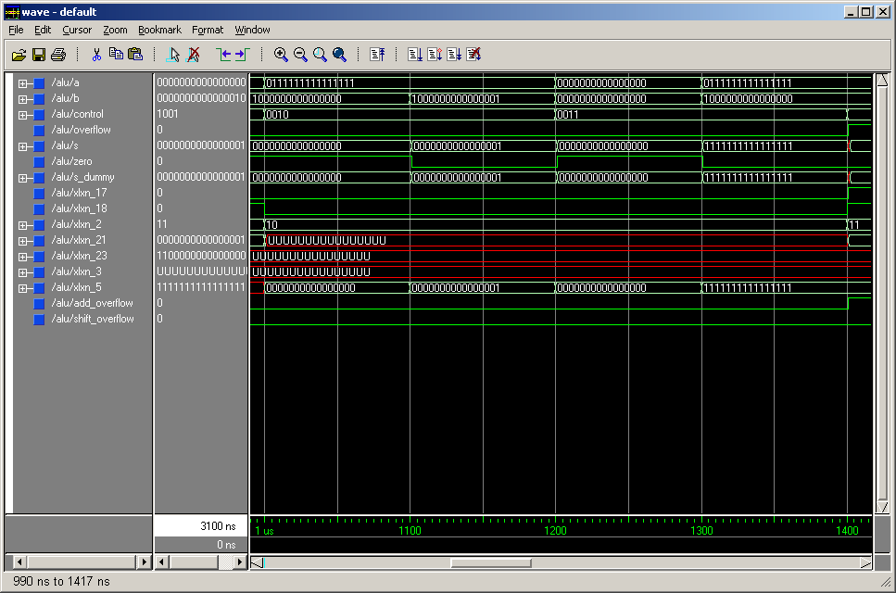
The sixth operation was incrementing 10, which resulted in 11. The seventh operation was decrementing 1, which resulted S equaled 0 and zero signal went high.
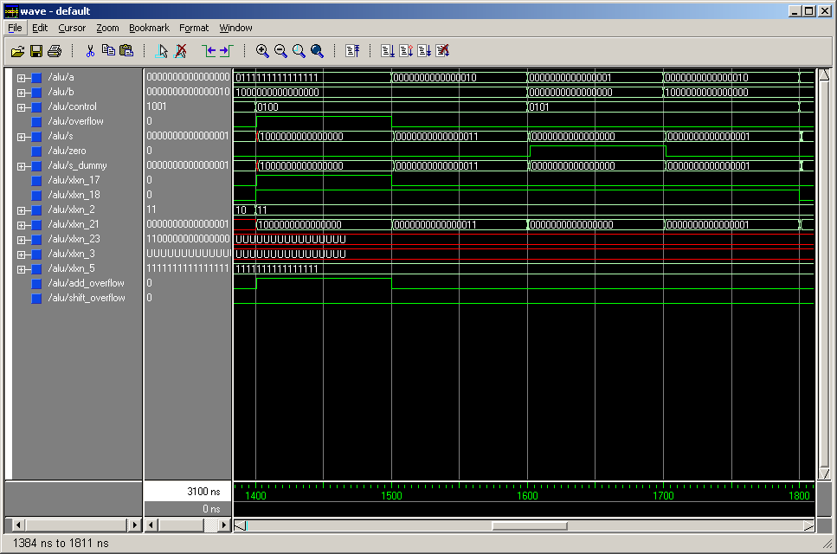
The eighth operation was 2’s complementing 111111111111111, which gave 1000000000000001. The rest were just some more examples.
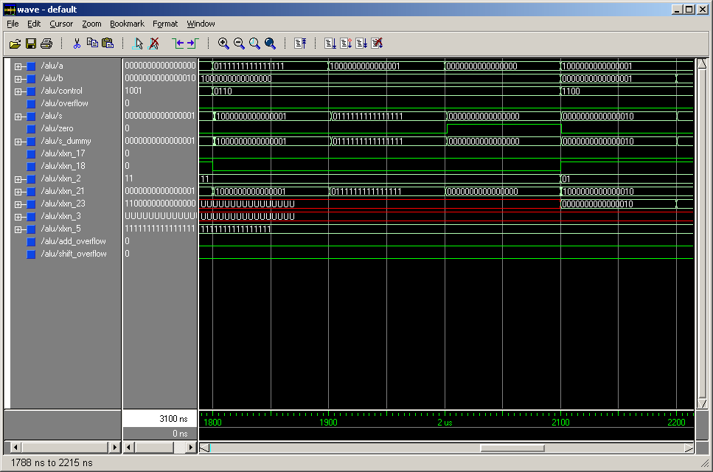
The ninth operation was left logical shift of 1000000000000001 one time, which resulted in 10. The tenth operation was right logical shift of 1000000000000001 one time, which resulted in 100000000000000. The rest were just some more examples.
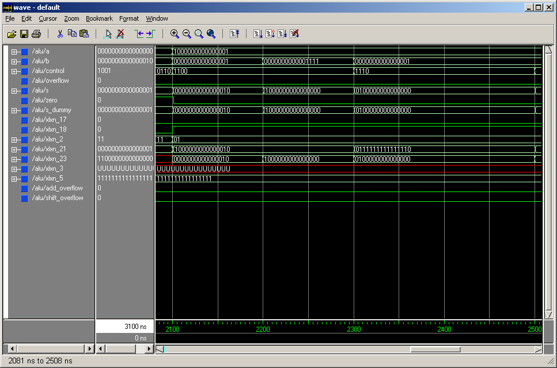
The eleventh operation was left arithmetic shift of 1000000000000001 one time, which resulted in 10. The twelfth operation was right arithmetic shift of 1000000000000001 one time, which resulted in 1100000000000000. The rest were just some more examples.

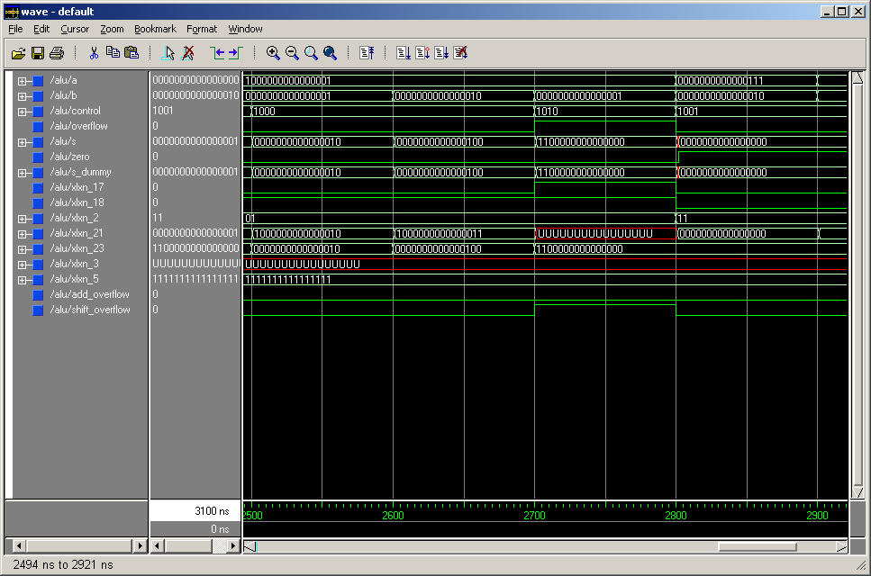
The thirteenth operation was comparing 111 and 10, which resulted in 0 since 111 was larger than 10. The rest were just some more examples.
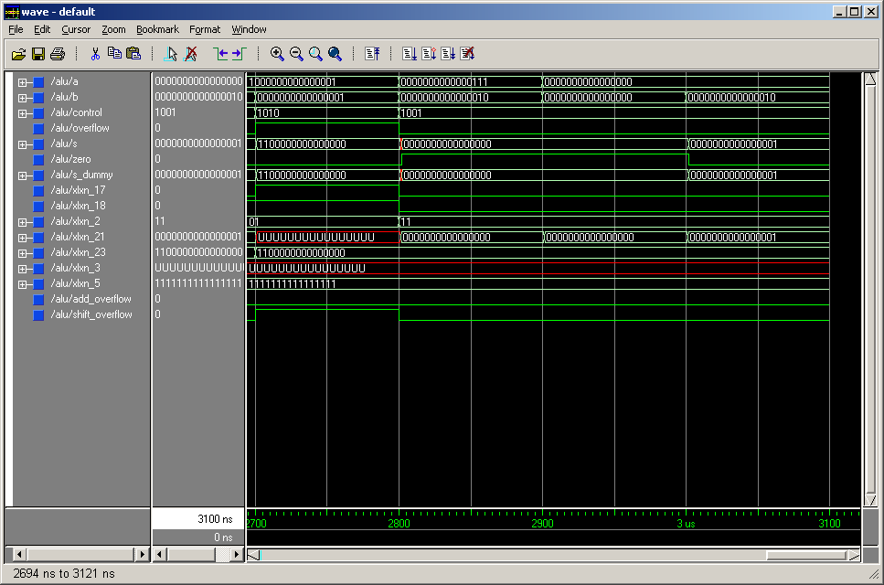

Register File:
The testing of the registry file was perform using the simulator tool provided in the main design development tool. The first test preformed was a write to each one of the registers. The result wave form can be seen here:

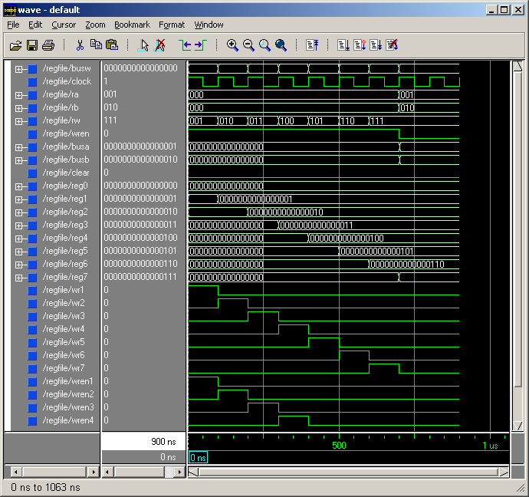
In this wave form the values from 0 to 7 have been written to the registry file. We had chosen the values equivalent to the register number for simplicity. The test can be repeated with the provided *.do file. In this case the equivalent file is: Reg-File-Test.do.

After being tested the writing operation of the register file, we followed to test the reading of two registers at the same time. The output of the test can be seen in the following wave form:

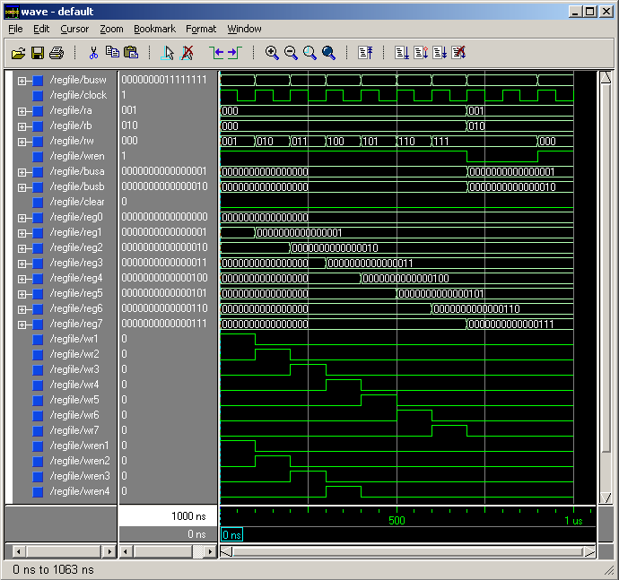

In this wave form image we can see that the input busses Ra and Rb have the values 001 and 010. At the same time the output busses BusA and BusB have the corresponding values from the register which are 00..001 and 00..010, which proves the properly functioning of the register file of reading two values simultaneously.

The last test performed to the register file was attempt to write to the register 0. For this we printed the signals screen shoot of the simulator showing the values attempted to be written. The busw is equivalent to 0…01…1, the clock is 1, the Rw is 000 and the value for write enable is 1, however, we ca appreciate that the value of Reg0 has not changed. This shows the successful functioning of the register file in all the test cases.

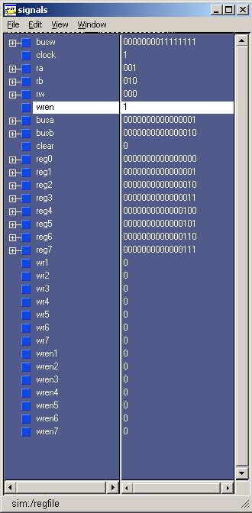

Memory Module:
DO file: memRead.do(memoryread.vhd)
Below, it was shown that the read state machine was going through all the stages as designed.
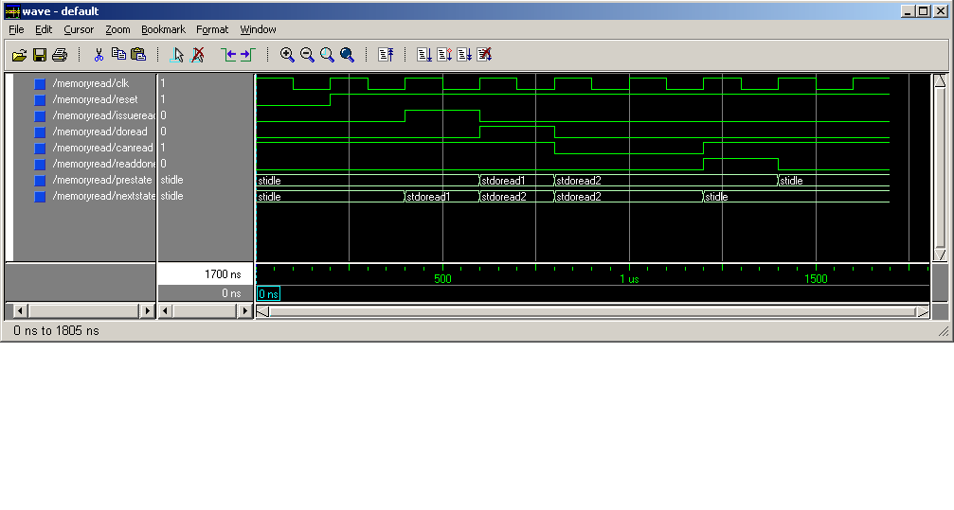
DO file: memWrite.do(memorywrite.vhd)
As shown below, the write state machine was going through all the stages as designed.
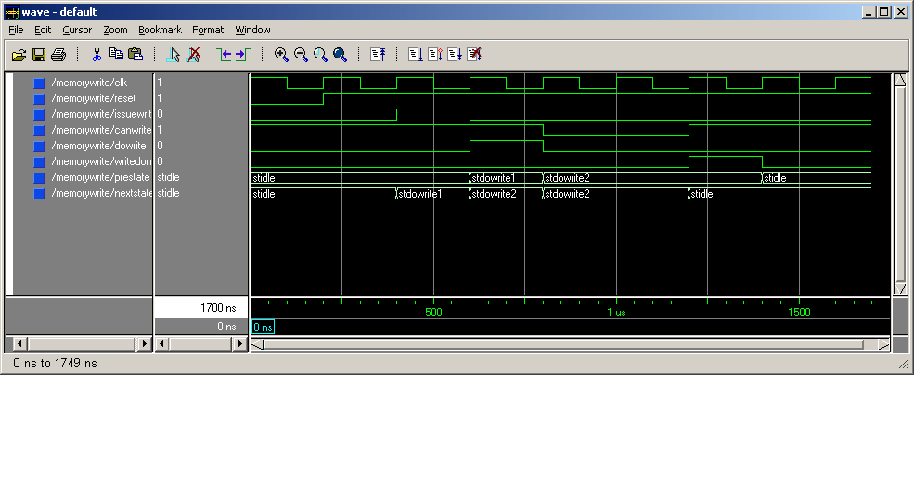
“Put it all together”
The logical connection between ALU, register file, memory module and simulator was shown above in the implementation detail part. In side the simulator, it was a state machine which generated output to the other units. First, the simulator filled in register one with value 1, register two with value 2… register seven with value 7. Then it read from register three, which contained a 3, and register five, which contained a 5, and put these data to the ALU which did an add operation. At the end of the same clock cycle, the output from the ALU, which was an 8 (3 + 5), was put back to register six and the SRAM at address 0. Writing to the SRAM took a few clock cycles and after it was done, the data from register seven, which was a 7, was stored to the SRAM at address 10. After the second write operation was done, data at address 0, which was the first ALU operation result, in the SRAM was read back and stored into register three. When the process was done, values in register three and register two, which were an 8 and a 2 respectively, were used in the ALU to do a subtract operation. At the end of the same clock cycle, the output from the ALU, which was a 6 (8 - 2), was stored back to the SRAM at address 1010. After the whole process was done, the state machine would reach and remain in its last state. A finish signal was used to indicate that the state machine has reached its final state. Finally, dump.exe was used to check back the data in the SRAM.
After downloading the whole design with the simulator on the board, everything worked fine except the read operation. The data read back from the SRAM, which should be an 8, stayed at the value of the last write operation, which was a 7. The ALU, register file and memory module were fully tested individually and they were all working fine. The problem with the read operation might be caused by the Xilinx program when it tried to optimize the timing of signals during “Implement Design.” To fix the problem, one clock cycle was needed to store the data from SRAM to any register after RdDone going high. In this way, delay was added to the design but it could meet all specifications required.

Slice Count
All together : 369 out of 768 → 48%
ALU alone : 185 out of 768 → 24%
Memory Module alone : 188 out of 768 → 24%
Register file alone : 124 out of 768 → 16%
SimModule alone : 60 out of 768→ 7%

Division of Tasks
ALU design: Yu, Wei Jun
Register File Design: Vega, Javier
Memory Module Design: Ho, Hing Kei
Simulator and “Put it all together” : Ho, Hing Kei, Vega, Javier, Yu, Wei Jun

Conclusion
There were a lot of things learnt in this project. First, VHDL code was elaborately used in this project, which gave us the chance to learn VHDL code very well. Second, the general ALU operation and its design were reviewed. What we learnt in the previous project was greatly useful in the ALU part of this project. Third, the design of the memory module was really challenging because it required us to fully understand what we did in tutorial two. Finally, although the SRAM read operation was not working as predicted, we could still read from the SRAM in a way that was slightly different from the protocol described in the specification.

